Descriptive Finding Guide for

**Fred Wallace Photo Collection**

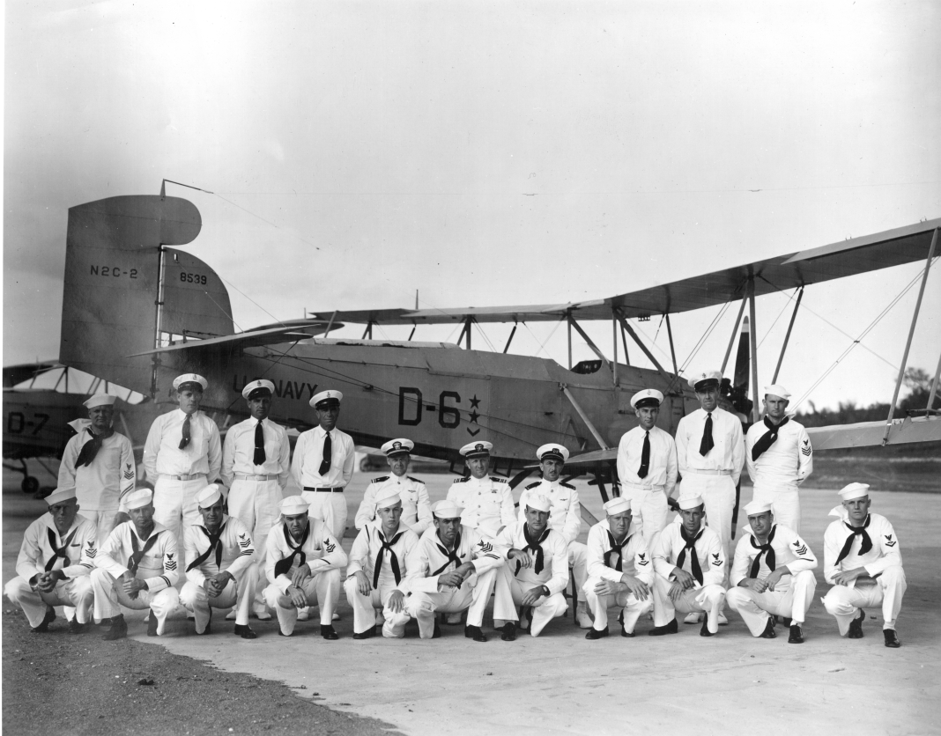

Prepared by: Alan Renga

Date: April 2, 2012

Updated by: Debbie Seracini

Date: October 13, 2014

**Cataloging Information**

Collection Number: SC.10153

Location: Archives

Restrictions: None

URL SDASM:<http://sandiegoairandspace.org/collection/item/fred-wallace-personal-papers>

URL OAC: <http://www.oac.cdlib.org/institutions/San+Diego+Air+and+Space+Museum+Library+and+Archives>

URL Flickr: <https://www.flickr.com/photos/sdasmarchives/sets/72157629861348693>

Copyright: SDASM

**Provenance**

The materials were donated to the San Diego Air & Space Museum on March 13, 2012.

The collection has been processed and is open for research.

________________________________________________________________________

**History**

Fred Wallace served in the US Navy as a Naval Enlisted Pilot (NAP) and was instrumental in the development and testing of drones and UAVs. He piloted the first drone, in 1937, from a control cart on the ground. This collection documents Wallace’s life as a fleet NAP, as well as early drone and UAV development.

_______________________________________________________________________

**Scope & Content Notes**

This collection documents Wallace’s life, as well as drone and UAV development. It primarily consists of photos, but also includes a scrapbook and documents.

**Important Personalities & Subjects**

Fred Wallace; UAV; Drones; Guided Missiles.

________________________________________________________________________

**Content & Series Description**

**SERIES I: Documents and Scrapbook**

**SERIES II: Photos**

____________________________________________________________________

**Box Listing**

**Box 1**

**Series I: Documents and Scrapbook**

1. Ship and aircraft identification notes in a binder

2. Stag Three Commissioning commemorative book

3. Scrapbook of newspaper articles relating to aviation

4. “The Birth of Guided Missiles” by Rear Admiral Delmar Fahrney, signed article

5. “The Genesis of the Cruise Missile” by Rear Admiral Delmar Fahrney, article

**Series II: Photos**

001 Interior of volcanic caldera

002 Volcano, crest and view into caldera

003 Captain Smith, VJ-6, NAS Clinton OK, 11Dec43

004 Beechcraft SNB VJ-6, 6-J-6 Drone control aircraft, 1943

005 USAF General UI

006 USN officer UI

007 Two USN officers Lt, left and officer from VS-41, right

008 Curtiss N2C-2 8538 VJ-3, D-6 Guantanamo, fleet maneuver support, 1939

009 Northrop BT-1 0630 VJ-3, 3-J-8 NAS San Diego, 16Dec39

010 Curtiss N2C-2 8527 VJ-3, D-5 Otay Mesa, 1939-40

011 Curtiss N2C-2 8536 VJ-3 Otay Mesa, damage to drone by USS Utah, 7May40

012 Curtiss N2C-2 VJ-3 Otay Mesa, 6May40

013 Vought O3U-6 VJ-3 Otay Mesa, 10Jan40

014 Northrop BT-1 0630 VJ-3, 3-J-8 NAS San Diego, 16Dec39

015 Great Lakes TG-1 8709 VJ-3 Otay Mesa, 20Sep39

016 New Standard NT-1 8587 NAF Philadelphia, 24Jun37

017 Beechcraft Model 18 NC19452 factory photo, proposed drone control aircraft

018 Great Lakes BG-1 VJ-5 line up of drones and Beech drone control planes, 1941

019 Douglas TBD-1 VJ-1F group photo

020 Stearman-Hammond JH-1 1937

021 Stearman-Hammond JH-1 1937

022 Great Lakes TG-1 VJ-3 radio control drone practice, Otay Mesa, 6May40

023 Vought O3U-6 VJ-3 Miramar, 1940

024 Group shot VJ-3 Guantanamo, fleet maneuver support, 1939

025 Group shot VJ-3 Guantanamo, fleet maneuver support, 1939

026 Northrop BT-1 0630 VJ-3, 3-J-8 NAS San Diego, 16Dec39

027 Curtiss N2C-2 8527 VJ-3, D-5 Otay Mesa, 1939-40

028 Curtiss N2C-2 VJ-3, D-44 Otay Mesa, 11May40

029 Curtiss N2C-2 VJ-3, D-44 Otay Mesa, 11May40

030 Curtiss N2C-2 sequence of aircraft shoot down

031 Curtiss N2C-2 sequence of aircraft shoot down

032 Curtiss N2C-2 sequence of aircraft shoot down

033 Lt. Cmdr. Ceremony

034 sketch Cuba, 1939

035 sketch Cuba, 1939

036 group photo NAF Philadephia

037 group photo NAF Philadephia

038 Lt. Comdr. Fred Wallace circa 1943

039 group photo VJ-6 4Jul43

040 Adm. King, SecNav Edison, Adm. Blandy USS Utah 23Apr40, Guantanamo

041 Northrop BT-1 0630 VJ-3, 3-J-8 NAS San Diego, 16Dec39

042 Beechcraft 18 VJ-3 tests as a drone control aircraft

043 Pitcarin Autogyro Hampton Roads, 14May29

044 DeHavilland DH.4B S-2, 2-13 NAS San Diego

045 Curtiss F6C-1 A-6972 VF-2, 2-F-3 NAS San Diego

046 Boeing F2B-1 VF-2, 2-F-1 NAS San Diego

047 Curtiss F6C-1 A-6972 VF-2, 2-F-3 NAS San Diego

048 USS Los Angeles NAS San Diego, 1924

049 Loening M-8-0 A-5842 NAS San Diego

050 Vought O3U-3 accident

051 Vought FU-1 VF-2, 2-F-9 NAS San Diego

052 Consolidated P2Y-1 VP-10F Pt. Fermin, 1934

053 Boeing Model 299 NX88W prototype F4B-3 export model

054 Martin XT5M-1 A-8050 factory

055 Boeing XF5B-1 NX271V

056 Vought UO-1 USS West Virginia

057 Vought UO-1 USS West Virginia

058 Vought UO-1 USS West Virginia

059 Boeing F2B-1 VF-2, 2-F-11 NAS San Diego, 1928

059 Boeing F2B-1 VF-2 Squadron line up, NAS San Diego, c1928

060 L to R: F.S. Wallace, Hite, Lt Cmdr. JH Smith, Ray, Lt. Baily, NAS Clinton, 6Aug43

061 Group shot VJ-6 officers of VJ-6; F.S.Wallace 2nd from left, Lt. E.R.Dare, center

062 Beechcraft 18 VJ-3 tests as a drone control aircraft, 30Mar40

063 Beechcraft 18 VJ-3 tests as a drone control aircraft, 30Mar40

064 Group shot VJ-6 officers of VJ-6

065 Curtiss N2C-2 8538 VJ-3, D-6 Guantanamo, fleet support, 1939 dupe of 008

066 group photo VJ-6 4Jul43

067 Curtiss Triplane

068 Vought UO-1 USS West Virginia

069 Vought UO-1 USS West Virginia

070 Vought O3U-6 VJ-3 Miramar, 1940

071 USS Los Angeles NAS San Diego, 1924

072 DeHavilland DH.4B 13Oct24, NAS San Diego, over Coronado - 2-14, Lt. Dupuy, 2-9, Lt. Schaeffer, 2-4, Lt. Seligman, 2-6, AP Wallace, 2-12, AP Williams

073 Hindenburg D-LZ129 Lakehurst, NJ

074 NAS Lakehurst hangar interior

075 Ryan NYP NX211NAS San Diego, 1927

076 Hindenburg D-LZ129 Lakehurst, NJ

077 Curtiss TS-1 catapult launch

078 NAS Lakehurst hangar exterior

079 Group shot 13Oct24, NAS San Diego, L to R:, AP Williams, Lt. Seligman, Lt. Dupuy, Lt. Schaeffer, AP Wallace

080 Group shot VJ-6 UI

081 Douglas Corrigan press photo

082 Group shot VF-2 NAS San Diego, names on photo

083 Group shot VF-2 USS Lexington

085 Group shot VF-2 NAS San Diego, 18Feb27

086 Group shot VF-2 NAS San Diego, 18Feb27

084 Group shot VF-2 NAS San Diego, 18Feb27

087 Pitcarin Autogyro Hampton Roads, 14May29

088 DeHavilland DH.4B negative image

089 Camp Townsend, NY 1919

090 Pitcarin Autogyro Hampton Roads, 14May29

091 Vought UO-1 USS West Virginia

092 AP Fred Wallace

093 Vought UO-1 USS West Virginia at NAS San Diego

094 rustic village photo UI

095 Sikorsky JRS-1 VJ-1, 1-J-5 group shot

096 Vought UO-1 USS West Virginia

097 Mountains UI

098 Beechcraft SNB VJ-6, 6-J-3 large print, group shot, 1943

099 Curtiss N2C-2 8538 VJ-3, D-6 large print, Guantanamo, fleet maneuver support, 1939 dupe of 008

100 Curtiss N2C-2 8526 large print

101 Class photo, USN Pre-Flight School, Chapel Hill, NC large print

**End Box Listing**