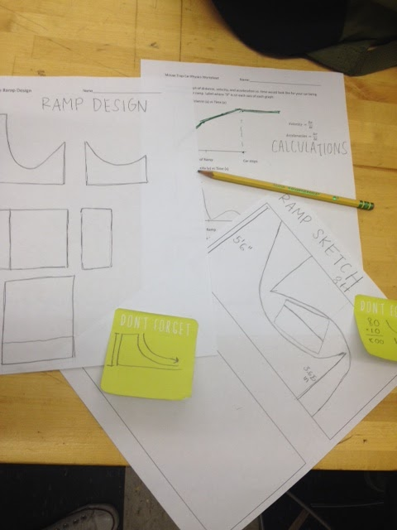
FLY-YOUR-RIDE
How HTHI approached the challenge

RAMP DESIGN - We started off making sketches of the ramp according to the specifications listed on the Fly Your Ride webpage. We made a side, a top and a front view sketch. In addition we also sketched graphs that estimated the distance, velocity, and acceleration of the car as a function of time during its trajectory. These graphs helped us understand the underlying physics needed to refine our vehicle designs. For example, realizing that the acceleration due to the force of gravity reverses at the bottom of the initial slope helped us design alternative power sources that would kick in strongest at that point.

THE CHALLENGE - The next step was to build the ramp itself. From our sketches it was clear that to cut the two side pieces of the ramp from a single piece of plywood, we would need a rectangular piece 7x6 feet. Since such sizes are not generally available, our teacher challenged us to figure out a way to get both sides out of a single sheet of standard 4’x8’ plywood. After some trial and error, we figured out it could be done if we allowed for splicing.

RE-DESIGNING - We used Adobe Illustrator for our final layout so that everything would be exactly to scale. Illustrator has tools to specify exact distances, radii, and angles. We learned to use the circle tool, how to make lines at an angle, how to crop with the scissor tool, and how to switch between appropriate scales. The cropped top parts of the ramp fit nicely into the vacant center of the layout.

Final Layout for the Ramp Sides (drawn to scale). 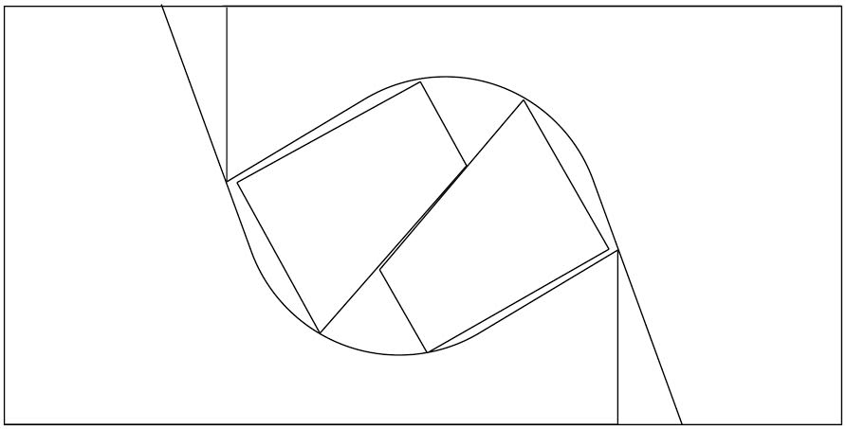

RAMP CONSTRUCTION
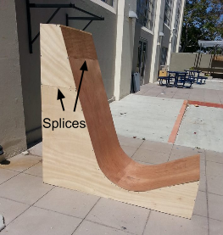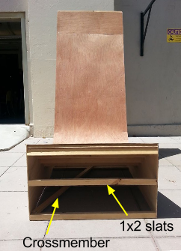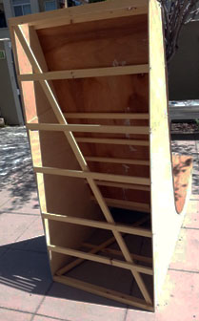

We transferred the layout in Illustrator to the plywood by first laying out the perpendicular line segments. We reproduced the angles by constructing various right triangles and applying trigonometric identities to find the lengths of the hypotenuses. We used thin plywood for the sides (¼”) to keep the ramp light and to make it easy to cut with a hand held saber saw. Once cut, the sides were connected to each other with slats of 1”x2” furring strips every foot or so (even closer in the region of the radius curve). The furring strips formed the foundation for the ramp surface which was cut from a ⅛” thick sheet of plywood. Splices were needed for the top pieces of the sides and for about one foot of the ramp surface. To increase the rigidity of the frame, furring strip crossmembers were added to the faces of the back, bottom, and front. These openings could have been covered with plywood but we found it unnecessary for stability. The resulting ramp was light enough for a single person to move easily (although it was much less awkward for two). One difficulty we had was bending the ramp surface into the radius curve without splintering the thin plywood. In retrospect, moistening the plywood with steam or damp towels would have made the wood more flexible and prevented splintering.
VEHICLE OPTIMIZATION
Once we had a ramp, we used it extensively to test and improve our vehicle designs. We often made slow-motion videos of our cars going down the ramp. Reviewing the videos, we could see exactly how our spring energy was being applied to the vehicle. For example, the string and mouse trap lever arm needed to be carefully optimized so that all the spring’s energy would be released before the vehicle left the ramp surface. We used the ramp and video analysis to evaluate many other parameters we thought might be important. Below are some of the adjustments we tested.
Wings: Some groups added wings to their car to give it some extra lift. We learned that wings needed to be sturdy and not provide so much lift that the vehicle could drift off line.
Extra Rubber bands: Some groups tied extra rubber bands to the end of the mousetrap to increase the tension. Some abandoned the mouse trap altogether, preferring a few thick rubber bands. Optimizing how to apply the extra torque on the wheels was tricky. Too much torque at the beginning tended to just make the wheels spin. We also learned there are limits to how much tension can be applied to the vehicle frames. The more tension, the more the frame would twist which often resulted in unpredictable off line trajectories.
Traction: Most groups learned they needed more traction especially at the beginning when the ramp was steepest (and the frictional force the lowest). A simple way to increase traction was wrap wide rubber bands around the outside of the wheels. In extreme cases, several wheels were glued together (“dualies”) to make them extra wide.
More weight: Since gravity provides a significant force accelerating the vehicle, more mass should produce more velocity. This prompted groups to add anything they could find to add weight to the center of the car. Of course, this had limits as well, especially on landing. Many axles were broken to learn these limits. We also learned that weight distribution was as important as the total weight. Moving small balancing weights fore and aft could have dramatic effects on the levelness of the trajectory, especially on designs using wings.
Axle diameter: By varying the diameter of the axle around which the string was wound, we learned we could match the amount of torque to the speed of the car as it descended the ramp thereby creating a crude type of transmission.
Stabilizers: In the beginning we had problems with our wheels sliding around when we launched our cars. To fix this we added plastic tubing and washers to prevent the wheels from wobbling.
We experimented with other factors including air power from balloons, lift from helium balloons, various wheelbases, and propellers. Most alternative power sources did not perform nearly as well as simply getting as much torque to the wheels as practical with springs and rubber bands. Wings were difficult to control and more often than not introduced more drag than lift.

