Descriptive Finding Guide for

Joseph H. “Joe” Famme Collection

(1911-2004)

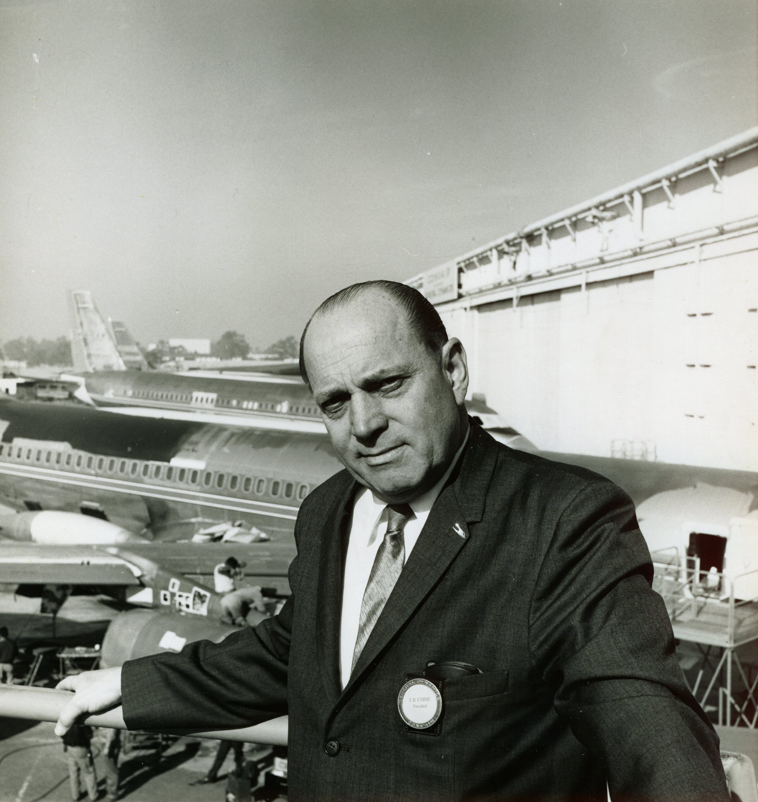

Prepared by: Robert E. Johnston
Date: February 10, 2011

Updated: 12 December 12, 2012
January 12, 2015

Cataloging Information

Collection Number: SC.10045
Location: Archives
Restrictions: None
URL Museum: http://sandiegoairandspace.org/collection/item/joseph-h.-famme-collection
URL OAC: http://www.oac.cdlib.org/institutions/San+Diego+Air+and+Space+Museum+Library+and+Archives
URL Flickr: https://www.flickr.com/photos/sdasmarchives/albums/72157640987117983
Copyright: SDASM
______________________________________________________________________________

Provenance

This extensive collection of both personal papers and published works was donated to the San Diego Air & Space Museum in April 2006, in the name of Joseph H. Famme, by the Convair Alumni Association Restoration Group at Gillespie Field. The collection consists of a number of Convair internal publications, engineering proposals, reports, correspondence, photographs, newspaper clippings, as well as other documents related to the design of major Convair aircraft such as the B-24, B-32, XB-46, F-102, F-106, 240/340/440 Convair Liners, and the Convair 880 four engine jet transport. The collection has been fully processed and is open for research with no restrictions.

_____________________________________________________________________________

History

Joseph H. Famme, a native of Baltimore, Maryland, born February 16, 1911, was a prominent contributor to the growth of the aerospace industry, especially in San Diego. He was an engineering and manufacturing executive, helping develop a wide variety of military and commercial aircraft for the Convair Division of General Dynamics and its predecessor companies, first joining Consolidated Aircraft Corporation in 1936. His many contributions spanned the period from just before the critical World War II years into the age of jet powered flight.

Famme studied engineering at Baltimore Polytechnic Institute and Johns Hopkins University, and worked at Fairchild Engine and Airplane Corporation at Hagerstown, Maryland, Sikorsky Aircraft Company, Bridgeport, Connecticut, as well the Glen L. Martin Company, Baltimore, Maryland. He joined Consolidated in San Diego as a draftsman in 1936, quickly advancing to positions of higher responsibility. In 1940, Famme was named an Assistant Project Engineer for the LB-30 program, advancing to Project Engineer for the LB-30 and B-24 in 1942. From 1943 to 1945 he was Chief Project Engineer for all B-24 aircraft programs. During this time he was also called to active duty as an officer in the Air Corps, serving as an advisor to General Doolittle to support outfitting and repair of B-24s planned for use in D-Day and related operations.

He was appointed Assistant Chief Engineer in 1954, guiding Convair during the transition to turbo-prop and jet engine aircraft, including the XB-46 bomber, XP-5Y and R3Y-1/2 seaplanes, and F-102 and F-106 interceptors, the backbone of U.S. air defense systems during the early Cold War years. Famme was Project Works Manager for the F-102 and F-106 production, and also headed the Convair production flight test facility at Palmdale, California. In 1961 he was named Vice President, Operations at Convair, and, later that year was named President of the Convair Division of General Dynamics. Mr. Famme retired from General Dynamics in 1966, joining Rohr as Vice President of Engineering, eventually retiring from Rohr in 1971.

He became a general contractor, developing commercial buildings. In semi-retirement he was particularly active supporting various community and philanthropic organizations, including significant service with the Grossmont School District Board of Directors and St. Luke’s Lutheran Church, and, he founded the Home for Guiding Hands in Lakeside, California. Famme also maintained his many professional affiliations, including the Society of Automotive Engineers, the American Institute of Aeronautics and Astronautics, the Navy League, Air Force Association, Association of the United States Army, and the American Ordnance Association. He was honored with a lifetime Achievement Award by the American Institute of Aeronautics and Astronautics in 2004. Mr. Famme died in Rancho San Diego, California on October 23, 2004.
______________________________________________________________________________

Scope and Contents

The collection contains 6 manuscript boxes of correspondences, newspaper articles, periodicals/publications, photographs, books and manuals, and technical information relating to Convair.

Important Personalities & Subjects

Astronautics Division; Atlas ICBM; B-24 Liberator Club; California Professional Resources Development Center; C-141A Empennage Contract; Consolidated Vultee Aircraft Corporation (Convair); Consolidated/Convair B-24, B-32, XB-46, XF-92A, F-102A/B, F-106A/B/C/D, 240/340/440, 880, 990; Japan Air Lines; Little Joe II Booster; Rohr Corporation; San Diego Navy League; The Tribune-Sun; U.S.S. Bennington (CVS20); Varig Airlines; William Tell Competition.

Ralph L. Bayless, John Bergstrom, B.F. “Sandy” Coggan, Red Covington, General J.V. Crabb, Scotty Doig, Frank Fink, W.W. Fox, C.W. Frick, C.F. Horne, Howard Hughes, Roger Lewis, R.C. Loomis, Chuck McCabe, General Joseph T. McNarney, Frank Pace, P. Peterson, Admiral M. Reynolds, Sparky Sebold, Bernie Simons, Ernest Stout, Admiral P.D. Stroop, H.C. Tafe, General J.F. Thorlin, Jim Wainwright, D.C. Wilkins, Max Yale.
______________________________________________________________________

Content & Series Description

Series I: Correspondence and Miscellaneous Papers
Series II: Newspaper Articles
Series III: Periodicals/Publications
Series IV: Photographs
Series V: Books and Manuals
Series VI: Technical Information
Series VII: Transferred from Collection
_____________________________________________________________________________

Box Listing

Box 1of 6

Series I: Correspondence and Miscellaneous Papers

1. B-24 Letters, Articles and General Information
2. Model 8 (F-102/F-106) Miscellaneous
3. Correspondence: Famme Promotion (1961)
4. Atlas/Astronautics General Historical Information
5. Correspondence: Famme Retires at General Dynamics and Joins Rohr (1966)
6. Rohr Staff Reduction Memorandum (1971)
7. State of California Aerospace Employment Issues (1971-1973)
8. California Space Shuttle Task Force (1973)
9. B-24 First Flight 50th and 60th Anniversary Proceedings (1989/1999)
10. Miscellaneous IAM Strike Information (1945 and 1987)
11. Famme Convair History Remarks (1982)
12. Famme Convair History Remarks (circa 1990s)
13. Convair Cartoons
14. Miscellaneous Papers/Thoughts
15. Grossmont School District/Other Public Service Recognition and Awards
16. Joe Famme Biographical Information
17. Personal Papers/Photographs
18. Original Famme SDASM Collection Inventory
19. Donations to CAA Restoration

Series II: Newspaper Articles

20. XF-92A – San Diego Union (November, 1952)
21. Consairways Articles
22. Miscellaneous Famme Articles (1952-1956)
23. Convair 50th Birthday (1973)
24. Howard Hughes Dealings with Convair (1976)
25. Demise of Convair San Diego Facilities (1992-1993)
26. David Grinnell, B-24 Pilot, Daily Mail (1997)

Box 2 of 6

1. The Tribune-Sun, Consolidated Dedication Day, 17 October 1941 (Complete Issue)

Series II: Periodicals/Publications

2. Consolidated Aircraft Corporation, Rules for Employees (1940)
3. Consolidated Vultee Aircraft Corporation Agreement with IAM Lodge 1125 (1941)
4. Consolidated Vultee Aircraft Corporation Agreement with IAM Lodge 1125 (1949)
5. Consolidated Vultee Aircraft Corporation, Factory Wage and Salary Classifications/ Labor Grades/Hourly Rates, circa 1949
6. New Cockpit Instrument Panel Design (1956)
7. Our American Government, History and Function (1963)
8. General Dynamics News - J. Famme Retirement Issue (February 1966)
9. Rohr News – Famme Joins Rohr (February, 1966)
10. Convair Management Club – 25th Anniversary Booklet (1967)
11. General Dynamics Hourly Employee Group Insurance Certificate (1970)
12. General Dynamics Shareholder Reports (1971-1972)
13. California Professional Resources Development Center, Final Report (1972)
14. General Dynamics, QAR Pocket Guide, Quality Assurance Reporting (July, 1974)
15. Convair Division Hourly Personnel Policies (Circa 1980)
16. Security Is Your Job – General Dynamics (Undated – Likely 1980s)
17. Flying Barn (B-24), Motor Home Magazine (Undated)
18. Keeping Convair Jobs Alive, DC-10 Barge Shipments, Los Angeles Times

Box 3 of 6

1. Newsletters, International Association of Machinists, Lodge 1125 (IAM), 1986-1992 (Incomplete)
2. Miscellaneous Internal Union “Unrest” Flyers
3. General Dynamics Heritage Chart (1987)
4. General Dynamics Safety Spotlight, circa 1989
5. General Dynamics World – Bill Anders Appointment (October 1989)
6. Orbiter (Newsletter), General Dynamics Space System Division (1991)
7. General Dynamics, Retirement Plan Booklet, Hourly Employees (1991)
8. Aerospace, Proposed MD-12
9. NMA Space Leader, March 1993, April 1993, December 1993
10. B-24 “All American” Brochure (not dated)
11. General Dynamics Manufacturing Services (not dated)
12. Atlas II Brochure (not dated)

Series IV: Photographs

13. Early Consolidated Aircraft Engineering Staff Picture (1935-1936)
14. J. Famme and Harvey Tafe at Consolidated Washington Office (1944)
15. Miscellaneous Joe Famme Photographs (1946-1960s)
16. J. Famme, F. Fink, E. Stout and Others with Unidentified Navy Officers (Ca. 1950)
17. J. Famme, Red Covington, Scotty Doig, Chuck McCabe
18. Final F-102 Delivery Ceremony – Joe Famme and Major General Jarred V. Crabb, Air Defense Command (1958)
19. Joe Famme in F-102 Flight Suit (with unidentified Air Force officer)
20. Convair 880 Roll Out Ceremony (1958)
21. Convair 880 Baggage Handing Exhibit - Joe Famme and Bernie Simons (circa 1959)
22. Convair Plant II Aerial Views
23. Convair Plant II Photographs (circa 1958)
24. Convair Plant II Interior Views (1959)

25. Convair Plant II Model 8 Final Assembly Line (F-102/F-106)
26. Hughes F-106 Avionics
27. F-106 Collins Electronics Replacement
28. F-106 Final Production Line, Building 307 (1959)
29. TF-102A – Joe Famme and Unidentified Air Force Pilot
30. Joe Famme and Numerical Controlled Machining Committee
31. Air Defense Command Ward Presentation – Joe Famme
32. U.S.S. Bennington (CVS 20) Ceremony – Joe Famme, Admiral Miller, R. Warden, P. Peterson, K. Smith and R. Loomis
33. Joe Famme in Factory Surroundings (1960-1962)
34. Japan Airlines Convair 880 Flight Crew (Undated)
35. Convair Service Pin Ceremony (Joe Famme, Sandy Coggan, Ralph Bayless and C. McDade)
36. General Kinnard, C.F. Horne, F.P. Kearns, Roger Lewis, E. Heinemann (likely Late 1960s)
37. William Tell Exercises Presentation – Joe Famme and Air Force (1961)
38. Martin Mariner with Vertical Floats Proposed as an ASW Platform in Rough Seas (1961)
39. J. Famme, Bill Dorrance, J. Wainwright, C.W. Frick, Bill Fox, D.C. Wilkins
40. San Diego Navy League (1975)
41. J. Famme and Ernie Kotnick
42. Joe Famme and Fred McLaughlin (1962)
43. Joe Famme, Admiral Max Reynolds, Charles F. Horn, Admiral Stroop (1962)
44. Japan Airlines Lines Convair 880 – Joe Famme and Japanese Navy Officers
45. Varig (Convair 990 Delivery) South American Trip (1963)
46. J. Famme and Frank Pace – American Airlines Convair 990 Astrojet
47. J. Famme at William Tell Exercises (F-106 Wins - 1964)
48. F-106B in Flight
49. A Better Future through Science and Engineering Meeting (Sparky Sebold, General Joseph T. McNarney, Frank Fink, Sandy Coggan and Others)
50. C-141 Empennage Contract Signing Ceremony - Joe Famme and Lockheed Georgia Company Executive (circa 1964)
51. Max Yale, Ralph Phillips, John Bergstrom and Departmental Party

Box 4 of 6

1. Little Joe II Launch Vehicle in Experimental Shop (Joe Famme and General Thorlin)
2. Joe Famme at President’s Award Ceremony (1964)

Series V: Books and Manuals

3. General Dynamics Telephone Directory (1974)
4. A Convair History, Desk Calendar (1989)

Series VI: Technical Information

5. Davis Wing (B-24) Technical Notes and Patent
6. B-32 Engine Run and Test Procedure (1945)
7. B-32 Inboard Profile, General Layouts and Schematics (Three view drawing, general arrangement, electrical system, flight control system, flight control surfaces, brake control system, fuel system and engine oil system)
8. XB-46 Serial Number 5-59582 History
9. F-106A/B/C/D Comparative Performance Information (undated)

Updated Information (Folders):

10. XP544
11. B-36 Papers and Information
12. F16
13. AF England Dinner Party Photos
14. Gen. Atomic News Article
15. Blue Prints 1 of 2 (Aircraft)
16. Blue Prints 2 of 2 (Aircraft)
17. Reps and 8th RF

Box 5 of 6

      - Metropolitan Manual
      - Organization Charts 1954
      - B-24 Liberation
      - Model 31 Seaplane
      - F-102
      - Model 22, 880 Jet
      - 2 Engine Transports
      - 990
      - 990/880 Schedule Performance
      - Staff Recommendations
      - Financial Report 1962-64
      - B-24 Liberation
      - B-24 Liberation Press

Box 6 of 6

- Liberator Picture
- General Dynamics Manuals
- B-17&B-24
- Cordova Hughes Aircraft Company
- Convair Modification Center / Legal Battle
- Letter
- PB4
- Xb*46 Book
- 1963 Review Book
- F16 Picture
- Wing in Ground 1970
- Engineers Ops 1944
- ROHR News

Series VII: Transferred from Collection

- Consolidator, January 1941
- Convairiety, 1948-1959 (Consolidated/Convair Bi-Weekly Newsletter – Incomplete)
- Convair Traveler (Model 240), Volume IV, Number 3 (July 1952)
- Interceptor Service News (F-102), Volume II, Number 2, 1957
- CS-61-047, Convair 880/990 Jet Airliners (1961)
- General Dynamics News – Volumes 14, 15, 16, 17, 19, 21, 22 (1961-1969), Includes Astronautics, Fort Worth, Pomona and San Diego Division Editions - Incomplete
- General aircraft system information manual, with sections previously published as articles for the “Convair Traveler”
- CS-58-010-1/2/3/4/5, Convair 880 Service Training Study Guide, Volumes 1/2/3/4/5
- General Dynamics Convair Research and Development Laboratories (1961), (Atlas ICBM) Base Activation Manual (Undated)
- General Dynamics World, Volume 2, Number 1 (1972); Volume 17, Number 6 (1987); Volume 19, Number 10 (1989); Volume 21, Number 4 (1991); Volume 22, Numbers 1-3 (1992); Volume 23, Numbers 1-2 (1993)
- General Dynamics Convair Weekly Log (Blue Sheet), 1984-1994 (Incomplete)
- CRA Balance Sheet, 1987-1994 (Incomplete)
- Briefing, Journal of the International B-24 Liberator Club, Numbers 39 (1988), 61-69 (1997-1999), 80 and 82- 83 (2002)
- QA Today (Newsletter), Convair Division (1992)
- USAIR Flight Operations Monthly (April, 1992)
- Take Notice, 1992 (Incomplete)
- Daily News Summary, 1992 (Incomplete)

End of Box Listing
______________________________________________________________________________

