Descriptive Finding Guide for

Birdie Draper Personal Papers

(1936-2005)

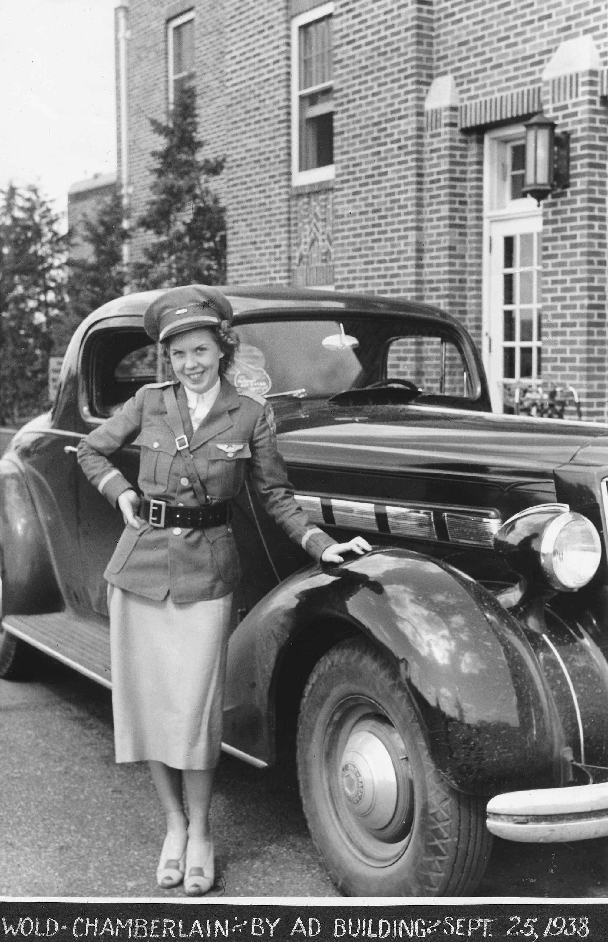

Prepared by: Katrina Pescador
January, 2006

Recent Update: Daniel Schlachet
December, 2014
Cataloging Information

Collection Number: SC.10039 O/S
Location: Archives
Restrictions: None
URL Museum: http://sandiegoairandspace.org/collection/item/birdie-draper-collection
URL OAC: http://www.oac.cdlib.org/institutions/San+Diego+Air+and+Space+Museum+Library+and+Archives
URL Flickr: https://www.flickr.com/photos/sdasmarchives/albums/72157650330477326
Copyright: SDASM

Provenance

The materials in this collection were donated to the San Diego Air & Space Museum in January, 2006. The collection has been processed and is open for research with no restrictions.

History

Birdie Viola Draper was born in 1916 in Minneapolis, Minnesota. In 1937 at the age of 20, Birdie began her training as a parachutist with Stub Chrissinger, an instructor for Hincks flying service. Mr. Chrissinger was one of two licensed parachute riggers in Minnesota at the time. After her training, Birdie joined a stunt group of Thrill Day Performers traveling to State Fairs. She was paired up with Captain F. F. (Bowser) Frakes who was best known for his daring plane crashing stunts. Birdie was recognized for crashing through sixteen sticks of dynamite with her car, as well as solid masonry walls. Her vast array of death defying stunts earned her the name, “The Queen of Daredevils.”

By 1940, Birdie completed thirty-five parachute jumps. She retired in 1941 as a daredevil once she received her license as a parachute rigger from the Department of Commerce. Shortly afterwards she took a position as a rigger for Ryan Aeronautical Company. Birdie married George Griffin, a local attorney, and retired from Ryan Aeronautical Company in 1945.

Birdie died on November 1, 2005.

Scope & Content Notes

This is a two box collection. The first box – containing folders with documents and photographs – measures 12 ¼” x 10 ½” x 5. The second box – containing two posters and a scrap book – measures 24 ½” x 20 ¾” x 3”. This collection was organized by material and subject type. The collection covers the life of Birdie Draper as a daredevil stunt performer and parachute rigger from 1936 to 1945. This collection contains posters, a scrapbook album, newspapers, correspondence, logbooks, manuals, and photographs.

Related SDASM Resources:
Tiny Broadwick Bio File

Important Personalities & Subjects

Parachute rigging; Stunt flying; automobile feats; Thrill Day Performaers; Aquatennial Air Show; “Devil With Wings”; F.F. Frakes (Bowser); Evans, Buddy; Ryan Aeronautical Company; Department of Commerce; Wold-Chamberlain; Marie McMillen; Tiny Broadwick.

Box Listing

Box 1 of 2
Folder 1 – Minn Aviation History, 1993
Scanned article of “Minnesota Aviation History,” 1857-1945, Noel E Ailand & Gerald N. Sandvick, MAHB Publ. Inc., 1993, pg 48-49.

Folder 2 – “My First Jump” by Birdie Draper
Eight page biography by Birdie Draper.

Folder 3 – Correspondence
This folder contains a variety of correspondence dating from 1939-1941, and 1947.

Folder 4 – Newspaper Article on Frakes
This folder contains several newspaper clips and articles on F.F. Frakes.

Folder 5 – Aviation Related Newspaper Clips
This folder contains several newspaper clips and articles on aviators and aviation news.

Folder 6 – Newspaper Articles on Women
This folder contains a wide variety of articles headlining women in stunt flying, parachuting, and aviation.

Folder 7 – Pioneer Parachute Club, Parts Catalog
- Pioneer Parachute Company Inc. Parts Catalog and Price List cover.
- Pioneer Parachute Company Inc. Parachute Technicians’ Bulletin.
- Three pages of Navy Department Bureau of Aeronautics Technical Note No. 32-42, April 13, 1942.
- Three pages of Navy Department Bureau of Aeronautics Technical Note No. 42-44, May 25, 1944.
- Five pages of the Department of Commerce Civil Aeronautics Administration, Safety Regulation Release No. 69, September, 1941.
- Nine pages of the Department of Commerce Civil Aeronautics Administration, Safety Regulation Release No. 110, May 21, 1942.
- Pioneer Parachute Packing Instructions, Models P1-B, P2-B, P3-B, P4-B.

Folder 8 – (Scanned) Jump Loop, 1937-1940
This folder contains twenty scanned pages of notes on parachuting.

Folder 9 – “The Interesting Story of Parachutes”
Small booklet about how parachutes work, how they are made, and how they are used.

Folder 10 – “Parachutes,” by J. Floyd Smith
Book about the development, use, and maintenance of parachutes.

Folder 11 – Irvin Manuals & Brochures
- Advertisement for Irvin Chair Chutes and Johnny’s Parachute Service.
- Service Manual for Irvin Air Chutes.
- Book titled “Irvin Air Chutes, Symbols of Safety.”

Folder 12 – Manual for all Models
Manual for All Models, Switlik Safety Chutes.

Folder 13 – Study Outline for Primary Ground Instruction
U.S. Civil Aeronautics Authority Study Outline for Primary Ground Instruction, September 1, 1939.

Folder 14 – Primary Ground Study Manual, 1939
U.S. Civil Aeronautics Authority Primary Ground Study Manual, September 1, 1939.

Folder 15 – Parachute Tech Regulation Booklet
Steele’s Aid to Parachute Technicians, Regulations. Chapters 25 and 54.

Folder 16 – Miscellaneous
This folder contains an assortment of documents and materials, including a ribbon, tickets, a story, advertisements, and a cardboard picture of Judy Garland.

Folder 17 – The Rip Cord Club
- Rip Cord Club of the World logo.
- The Rip Cord Club of the World certificate No. 533.

Folder 18 - Photographs
- Eleven photographs of Stub tutoring Birdie – from medical exam, to spilling and folding a parachute.
- Birdie in uniform by car.
- Birdie and Frakes (with her story in the newspaper).
- Birdie, Frakes, and Stub looking at photographs.
- Dynamite Crash.
- Frakes Portrait.
- Birdie and Jack.
- Four photographs of Frake’s plane crashes.
- Jumpers after landing.
- Crew gathering with group signature.
- Frakes and plane.
- Frakes, Birdie, car, and dogs.
- Shadow (roller derby) signed.
- Birdie crashing into a brick wall, 1938.
- Birdie chuted up, St. Clair, Minn., 1939.
- Birdie in uniform next to a car – Wold Chamberlain, 1938.
- Two photographs of the Minneapolis Aquatennial, July 1940.
- Birdie’s first jump, 1937.
- Birdie’s 13th practice jump.
- Birdie in uniform in front of the brick wall she crashed, 1938.
- Miscellaneous thrill show.
- Birdie practicing jumping, St. Clair, 1939.
- Birdie, plane, and child.
- Two group photographs with names.
- Birdie in uniform standing next to a Taylor Cub, 1938.
- Two photographs of Birdie in 1939, one with Frakes and the plane, one without Frakes (plane crash she didn’t make with Frakes).
- “Reckless” Rex Murphy, the Thunderbolt test driver.
- Three photographs of Chuck Doyle and his planes.

Folder 19 – Parachute Log (1)
This folder contains two parachute logs. The black covered log is empty. The blue covered log spans from October, 1941 to July, 1943.

Folder 20 – Parachute Log (2)
This folder contains a parachute log dating from November, 1941 to January 12, 1943, and a flipbook notepad.

Folder 21 – Parachute Log (3), 1939
This folder contains a Parachute log dating from August, 1939 to May, 1941.

Box 2 of 2

- Poster of the First Annual Parachute Circus at Camp Kearny Mesa, San Diego, CA, featuring Miss Birdie Draper. Sunday, October 19, 1941.
- Painted rally poster – do not open.
- Scraper Board scrapbook (unbound). It consists of twenty double sided pages (24 inches long), and contains newspaper articles and clips, a map, a logo, and magazines.

End of Box Listing

