Descriptive Finding Guide for

**John Dohm Personal Papers**

**(1916 - 1986)**

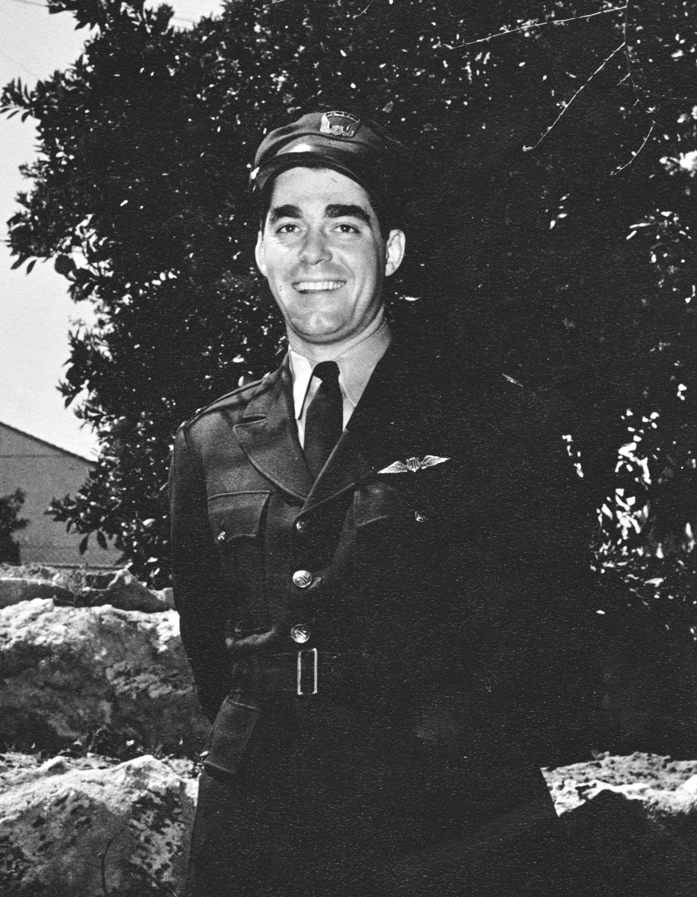

Prepared by:Kimberly Luna

April 23, 2015

Updated by: Jessica Herron

April 30, 2015

**Cataloging Information**

Collection Number: SC.10037

Location: Archives

Restrictions: None

URL SDASM: <http://sandiegoairandspace.org/collection/item/john-dohm-personal-papers>

URL OAC: <http://www.oac.cdlib.org/institutions/San+Diego+Air+and+Space+Museum+Library+and+Archives>

URL Flickr:<https://www.flickr.com/photos/sdasmarchives/sets/72157652704380718>

Copyright: SDASM

**Provenance**

The materials in this collection were donated to the San Diego Air & Space Museum in April 2013. The collection has been processed and is open for research with no restrictions.

**History**

John Dohm was born on September 5, 1916 in Bloomington, Illinois; the son of Louis and Gertrude Killian Dohm. He graduated from Trinity High School in Bloomington, and attended Illinois State University.

He was an author, navigator for TWA, aviation consultant, editor, and Technical Director of Pan American Navigation Service. Dohm also served with Air Transport command during WWII as a navigator.

Dohm married Rachel Zweng, of Glendale, California in 1940 with a small ceremony of only friends and family. Shortly after their honeymoon, they lived at 853 West North Street, in Decatur, Illinois. Rachel’s father, Charles A. Zweng, was a recognized authority on air navigation and former instructor in the U.S. Army Air Corps. He was also the founder and director of the Pan American Navigation Service in North Hollywood, California.

John Dohm died in Cambridge, England on August 11, 1986 while attending a summer session at Cambridge University.

**Scope & Content Notes**

This collection is a combination of memorabilia from three different family members: John Dohm, his wife Rachel Zweng Dohm, and his father-in-law, Charles Zweng. One archive box (12.25”x10.25”x2.5”) contains 5 folders with magazine articles, manuscripts, flight maps, newspaper clippings, and photographs from 1940s to 1980s that had belonged to John Dohm.

One oversize box (20.75”x16.75”x3”) contains one photo album that had belonged to Rachel Zweng Dohm, two scrapbooks that had belonged to Charles Zweng, as well as one photographic portrait and one “shellback” certificate that both had belonged to John Dohm.

**Related SDASM Resources:**

None

**Important Personalities & Subjects**

PacAero Learstar;

**Series Description**

SERIES I: Newspaper and Magazine clippings

SERIES II: Manuscripts

SERIES III: Maps

SERIES IV: Photographs

SERIES V: Scrapbooks

SERIES VI: Certificate

**Box Listing**

**Box 1 of 2**

**Series I: Newspaper and Magazine clippings**

**Folder 1** – **Newspaper Clippings & Press Releases**

1. *S.C. Publisher Earns Award*, article about Pan American Navigation Service Inc. with unknown author (no date).
2. *John Dohm to Address Flying Club*, article about John Dohm’s visit to the Icarian Flying Club with unknown author (no date).
3. *How Time Flies*, excerpt celebrating one of John Dohm’s flights (unknown author), November 17, 1982.
4. *Flying Club to Hear Pole Pilot*, article about one of John Dohm’s flights (unknown author), August 12, 1959.
5. *How Time Flies*, excerpt celebrating on of John Dohm’s flights (unknown author), November 17, 1982.
6. “Views in the Valley”, news column about John Dohm, by Charles Page, August 10, 1959.
7. *Plane Built in Santa Monica Claims Record*, article about the PacAero Learstar’s transpolar flight to Germany (no author or date).
8. *Plane Built in Santa Monica Claims Record*, article about the PacAero Learstar’s transpolar flight to Germany (no author or date).
9. *Entertains New Mexico Guest*, photograph of Rachel Zweng, August 3, 1934.
10. “Lear’s L-102 Autopilot Flies First Twin-Engine Plane on Transpolar Route”, news release from Lear Incorporated, November 12, 1957.
11. Green “Press” ribbon pin.
12. Three copies of “PacAero Learstar Sets Business Aircraft Record” from Charlotte De Armond for Pacific Airmotive Corporation.

**Folder 2 – Magazine Articles**

1. “Check Flight” packet of articles about the PacAero Learstar, July 1958.
2. “Learstars” advertisement for the PacAero Learstar, January 1958.
3. *First Learstar Makes Transpolar Flight*, by Lloyd Walker, April 1958.
4. *PacAero Learstar Sets Aircraft Record*, from Aero Trading Post, April 1958.
5. “First business plane flies polar route with B.F. Goodrich De-Icers” advertisement for B.F. Goodrich De-Icers, April 21, 1958.

**Series II: Manuscripts**

**Folder 3 –** **Manuscripts**

1. *Oliver Pestle and the Bloody Angels*, by John Dohm (no date).
2. *Twenty Years with the Wrong Adverb*, by John Dohm with edits in pencil (no date).
3. Short story about an aircraft workers’ strike under President Franklin Delano Roosevelt’s administration with edits (no date).
4. “First Broadcast: Chamber Music Society of Lower Basin Street, February 11, 1940”, by John Dohm, 1941.
5. *The Affair of the Mammounia*, by John Dohm with edits in pencil (no date).
6. *A Season in Morocco*, by John Dohm (no date).
7. *An Introduction to Henry George*, by John Dohm with edits in pencil (no date).
8. *A Season in Morocco*, by John Dohm with edits in pencil and pen (no date).
9. *Evening Song*, by John Dohm with pencil edits and an address (no date).
10. *A Daydream* poem by unknown author (no date).

**Series III: Maps**

**Folder 4** – **Flight Map/Plane**

1. Flight plan and log from Frobisher to Dusseldorf, November 8, 1957.
2. Flight plan and log from “SMO” to “CYFB”, November 8, 1957.
3. Aircraft position chart for the North Atlantic used for trip from Frobisher Bay to Dusseldorf, November 8, 1957.
4. U.S. Air Force aeronautical planning chart used for trip from Santa Monica to Frobisher Bay, November 8, 1957.

**Series IV: Photographs**

**Folder 5** – **Photographs**

Folder contains twenty photographs of a Learstar “D-COCA” plane, with a letter from Harry Graybill of Lear, Inc., c. 1956.

1. Letter to John Dohm from Harry G. Graybill describing the photographs, July 24, 1956 (signed in ink).

**Box 2 of 2, Oversize**

1. One oversized photographic portrait of John Dohm.
2. One small photo album that belonged to Rachel Zweng Dohm.

**Series V: Scrapbooks**

1. Two large scrapbooks that belonged to Charles A. Zweng containing correspondence, newspaper clippings, and photographs.

**Series VI: Certificate**

1. One “shell back” certificate issued to John Dohm, Nov. 21, 1942.

**End of Box Listing**