Descriptive Finding Guide for

**Consolidator**

**Periodical Collection**

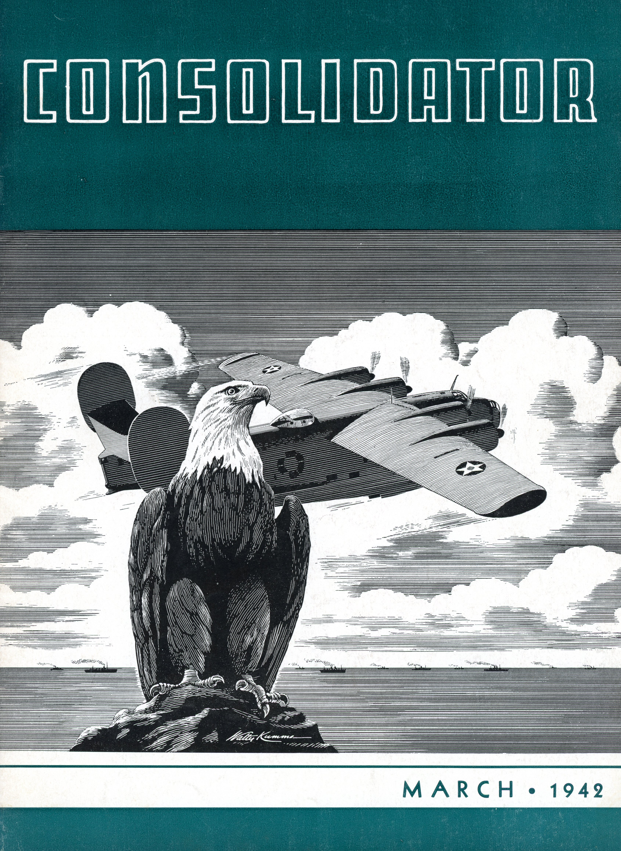

Prepared by*:* Daniel Schlachet

August 29, 2016

**Cataloging Information**

Collection number: SC.10174

Location: Annex

Restrictions (all collections): None*.*

URL SDASM: <http://sandiegoairandspace.org/collection/item/consolidator-periodical-collection>

URL OAC: <http://www.oac.cdlib.org/institutions/San+Diego+Air+and+Space+Museum+Library+and+Archives>

URL Digitized Periodicals: <https://archive.org/details/sandiegoairspacemuseum>

Copyright: SDASM

**Provenance**

The materials in this collection were donated to the San Diego Air & Space Museum (or the San Diego Aerospace Museum prior to mid-2006) in the past few decades. The collection has been processed and is open for research with no restrictions.

**History**

In September 1939, the inaugural edition of CONSOLIDATOR was unnamed. Two days after the first issue was released, the Consolidated Aircraft Corporation company picnic was held at Mission Beach with over 5600 people in attendance. It was there that the winners of the naming contest were announced. H. Miller of the wing department, W.H. Wellman of sheet metal, A.D. Kligman of engineering, and telephone operator Blanche Davis, submitted the winning name of “Consolidator” out of the one thousand and fifty-one entrants. In the first issue, Major Reuben H. Fleet commented on the trend of industrial institutions publishing in-house magazines for the purpose of keeping in touch and creating a closer relationship with their employees. The magazine was published on a monthly basis by and for employees of Consolidated Aircraft Corporation until April 1942 when it went to quarterly publication. In addition to the quarterly CONSOLIDATOR, a weekly newsletter, “The Consolidated News,” was issued to publicize plant news.

**Description & Content Notes**

**Description:** This is a one box collection with dimensions 12 ¼ x 10 x 7 inches. The collection contains 67 Consolidator magazine newsletters.

**Content notes:** The entire collection is magazine newsletters. It is organized by date, starting from October 1936 and ending in April 1942.

**Related SDASM Resources:**

The Consolidators have been digitized and can be found online:

<https://archive.org/details/sandiegoairspacemuseum>

Consolidated newsletter collection

Pescador, Katrina, and Mark Aldrich. Consolidated Aircraft Corporation. Charleston SC: Arcadia, 2008. Print.

Aerocat (EOS) search “Consolidated” <http://s92006.eos-intl.net/S92006/OPAC/Search/SimpleSearch.aspx>

**Important Personalities & Subjects**

Aircraft Manufacturing; Aerospace Engineering; Aerospace Industry; Consolidated Aircraft Corporation; Aircraft Mechanics; Aircraft Maintenance.

**Series Description**

This is a one series collection of Consolidator magazine newsletters. The collection is organized by date.

**Box Listing**

**Box 1 of 1**

Folder 1 – Consolidator October 1936 – December 1936

Folder 2 – Consolidator January 1938 – December 1938

Folder 3 – Consolidator January 1939 – December 1939

Folder 4 – Consolidator January 1940 – June 1940

Folder 5 – Consolidator July 1940 – December 1940

Folder 6 – Consolidator January 1941 – July 1941

Folder 7 – Consolidator August 1941 – December 1941

Folder 8 – Consolidator January 1942 – April 1942

**End of Box Listing**