Descriptive Finding Guide for

Air Force Special Collection

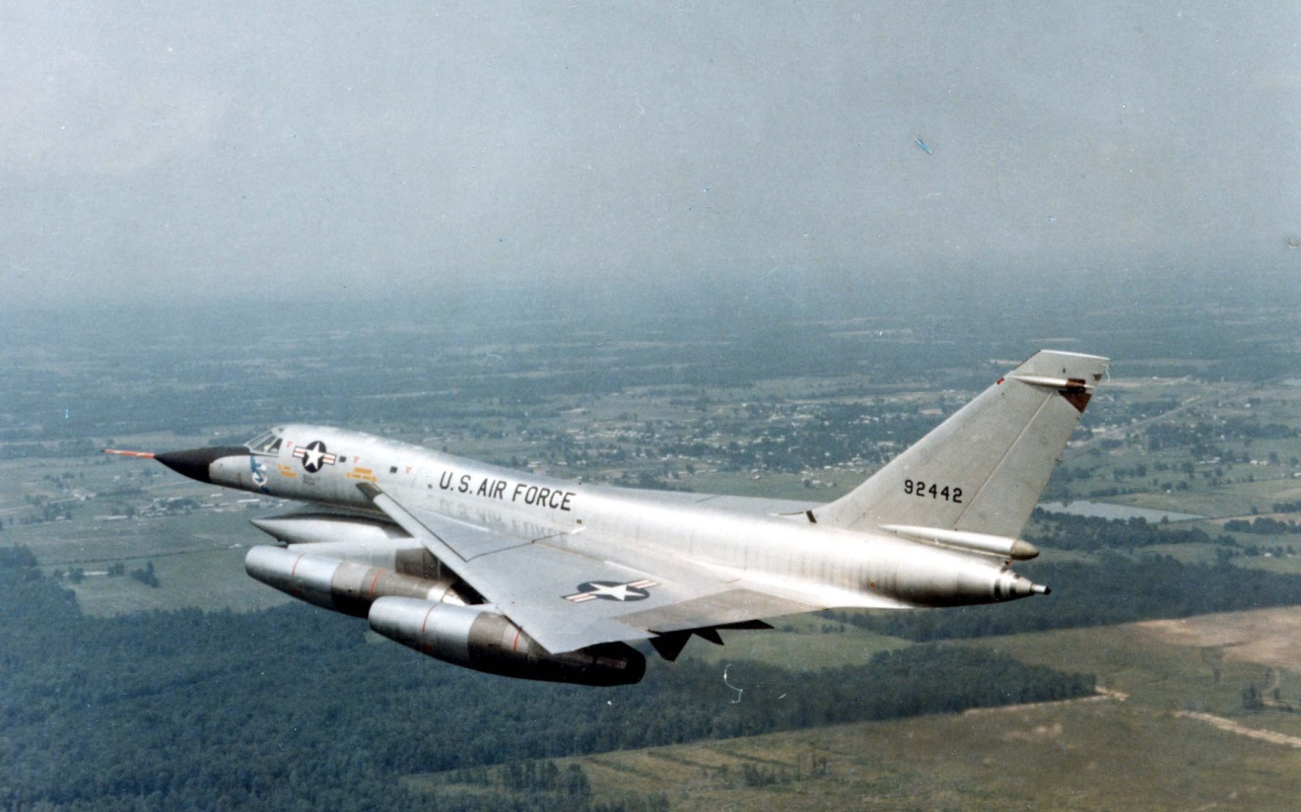

Prepared by:Casey Wimpey
February 15, 2015

Cataloging Information

Collection Number: SC.10001
Location: Archives
Restrictions: None
URL SDASM: http://sandiegoairandspace.org/collection/item/united-states-air-force-collection
URL OAC: http://www.oac.cdlib.org/institutions/San+Diego+Air+and+Space+Museum+Library+and+Archives
URL Flickr: https://www.flickr.com/photos/sdasmarchives/
Copyright: SDASM

Provenance

The materials in this collection were donated to the San Diego Air & Space Museum. The collection has been processed and is open for research with no restrictions.

History

The history of the United States Air Force is quite distinguished. Oringally designated as the Signal Corps, the Air Force grew during the First World War and was a named the Army Air Corps. Between the World Wars, the Army Air Corps developed new technologies which would serve the branch well in the Second World War, when it was a deciding factor in the victory over the Axis. The Air Corps officially became the United States Air Force in 1947 and sense that time it participated in every major armed conflict the United States was involved in.

Scope & Content Notes

The collection contains information pertaining to the history of the US Army Air Corps and the United States Air Force. It includes general history, as well as subject folders on different wings, groups and squadrons. This collection has much information in it on somewhat obscure topics related to the USAF.

Related SDASM Resources:

Aircraft Subject Files
World War One Subject Files
World War Two Subject Files

Important Personalities & Subjects

Series Description

SERIES I: Squadrons, Wings, Commands
SERIES II: General History and Topics

Box Listing

SERIES I: Squadrons, Wings, Commands

Box 1 of 6

Folder #1: Misc. fighter squadrons
Folder #2: 1st bombardment squadron
Folder #3: 1st pursuit group
Folder #4: 1st air commando group
Folder #5: 2nd bombardment squadron
Folder #6: 2nd air force
Folder #7: 3rd air force USAFE
Folder #8: 3rd observation squadron
Folder #9: 3rd attack group
Folder #10: 4th tactical fighter wing (4th fighter wing)(USAFE)
Folder #11: 5th bomb wing
Folder #12: bomber barons
Folder #13: 5th air force
Folder #14: 5th SRW Travis AFB 23,31,72 bomb squadrons, 9th BW, 1st BS
Folder #15: 6th BW 24,39,40 Walker AFB bomb squadrons
Folder #16: 6th ferrying group
Folder #17: 7th air force
Folder #18: 7th BW 9, 436, 492 carswell AFB bomb squadrons
Folder #19: 7th bomb group USAF
Folder #20: 8th air force
Folder #21: vii fighter command
Folder #22: 8th fighter (pursuit) group
Folder #23: friends of the 8th (fote)
Folder #24: 8th commands USAF
Folder #25: 8th air force
Folder #26: 9th aero squadron
Folder #27: 9th air force
Folder #28: 10th tactical reconnaissance wing
Folder #29: 10th tactical fighter squadron, 50th TFW USAFE
Folder #30: 10th air force
Folder #31: 11th air force
Folder #32: 11th bombardment squadron (air corps)
Folder #33: 11th BW 26,42,98 carswell AFB bomb squadrons
1) Papers about the air force association
2) 3 books about the 11th bombardment wing

Box 2 of 6

Folder #1: 12th air force
Folder #2: 12th photoreconnaissance
Folder #3: 12th bomb group
Folder #4: 13th A.F.
Folder #5: flying tiger association
Folder #6: 14th air force
Folder #7: 14th/15th military airlift squadron
Folder #8: 15th air force
Folder #9: 15th bomb squadron
Folder #10: 17th air force
Folder #11: 17th pursuit squadron (USAAF)
Folder #12: 17th tactical reconnaissance squadron, 26th TRW USAFE
Folder #13: 18th tactical fighter wing
Folder #14: 19th bomb group
Folder #15: 17th/20th provisional pursuit squad
Folder #16: xix tactical
Folder #17: 20th air force
Folder #18: 20th tactical fighter wing (20th fighter group)
Folder #19: 21st air force
Folder #20: 22nd bombardment wing
Folder #21: 22nd military airlift squadron
Folder #22: 23rd fighter group CBI- SW PAC
Folder #23: 23rd tactical fighter squadron, 52nd TFW USAFE
Folder #24: 26th tactical reconnaissance wing zweibruckew AB, Ger. USAFE
Folder #25: 27th fighter group
Folder #26: 28th SWR Ellsworth AFB 77, 717,718 bomb squadrons
Folder #27: 28th bombardment wing
Folder #28: 29th bomb group USAAF
Folder #29: 30th bomb group
Folder #30: 30th tactical reconnaissance squadron, 10th TRW USAFE
Folder #31: 31st air division
Folder #32: 31st tactical fighter wing
Folder #33: 32nd tactical fighter squadron, 2 ATAF USAFE
Folder #34: 32nd tactical reconnaissance squadron, 10th TRW USAFE
Folder #35: 33rd photoreconnaissance squad
Folder #36: 33rd tactical group
Folder #37: 35th tactical fighter squadron
Folder #38: 36th tactical fighter wing
Folder #39: 37th fighter interceptor squadron
Folder #40: 38th tactical reconnaissance squad, 26th TRW USAFE
Folder #41: 39th fighter squadron
Folder #42: 40th bomb group
Folder #43: 41st fighter squadron
Folder #44: 42nd BW loring AFB 69, 70, 75 bomb squadrons
Folder #45: 44th bomb group
Folder #46: 44th fighter squadron “vampires”
Folder #47: 47th bombardment wing (light) RAF sculthorpe USAFE
Folder #48: 48th tactical fighter wing RAF lakenheath USAFE
Folder #49: 49th tactical fighter wing
Folder #50: 50th squadron
Folder #51: 50th tactical fighter wing Hahn AB
Folder #52: 50th troop carrier wing
Folder #53: 51st fighter group
Folder #54: 54th troop carrier squad
Folder #55: 55th fighter group (55th Strategic recon. Wing)
Folder #56: 55th air service group
Folder #57: 56th fighter group
Folder #58: 58th fighter group
Folder #59: 58th bomb wing
Folder #60: 62nd fighter interceptor squadron
Folder #61: 62nd troop carrier group
Folder #62: 63rd military airlift wing
Folder #63: 67th aerospace rescue and recovery squadron (MAC) RAF Woodbridge USAFE
Folder #64: 72nd SWR ramney AFB 60, 73, 301 bomb squadrons
Folder #65: 73rd bomb wing
Folder #66: 74th fighter squadron
Folder #67: 78th fighter group
Folder #68: 79th pursuit squadron
Folder #69: 80th fighter group
Folder #70: 80th fighter squadron
Folder #71: 80th fighter squadron
Folder #72: 81st tactical fighter wing RAF bentwater (RAF Woodbridge) USAFE
Folder #73: 81st tactical fighter squadron, 52nd TFW USAFE

Box 3 of 6

Folder #1: 90th bomb group
Folder #2: 86th fighter group
Folder #3: 91st bomb group
Folder #4: 92nd BW Fairchild, AFB 325,326,327 bomb squadrons
Folder #5: 94th bomb group
Folder #6: 94th pursuit squadron
Folder #7: 95th bombardment squad. (MED) USAAC Pendleton field, Oregon
Folder #8: 95th pursuit squadron
Folder #9: 96th bomb group
Folder #10: 96th pursuit squadron
Folder #11: 97th bombardment group
Folder #12: 99th bomb group
Folder #13: 105th fighter squadron
Folder #14: 108th tactical fighter wing
Folder #15: 110th squadron (observation bombardment)
Folder #16: 118th tactical Airlift wing
Folder #17: Army air force 125th liason squad
Folder #18: 129th air resupply group
Folder #19: 138th aero squadron
Folder #20: 146th tactical airlift wing
Folder #21: 141st aero squadron
Folder #22: 148th aero squadron
Folder #23: 213th aero squadron U.S.A.S.
Folder #24: 302nd squadron “red tail” Tuskegee airmen
Folder #25: 305th bomb group
Folder #26: 306th bomb group
Folder #27: 308th airdrome squadron
Folder #28: 310 (1945)
Folder #29: 313th bombardment wing
Folder #30: 313th tactical fighter squadron 50th TFW USAFE
Folder #31: 314th air division (formerly 314th bomb. wing)
Folder #32: 316th air division
Folder #33: 317th troop carrier squadron
Folder #34: 319th fighter interceptor squadron
Folder #35: 320th bombardment group
Folder #36: 323rd bomb group
Folder #37: FM-2 general motors
Folder #38: 334th tactical fighter squadron 4th TFW TAC
Folder #39: 345th bomb group
Folder #40: 352nd fighter group
Folder #41: 354th fighter group
Folder #42: 355th fighter group
Folder #43: 355th TAC fighter wing
Folder #44: 357th fighter group
Folder #45: 461st and 484th bomb group assoc.
Folder #46: 363rd tactical recon wing
Folder #47: 374th bomb squadron (H)
Folder #48: 432nd fighter squadron
Folder #49: 376th bomb group
Folder #50: 379th bombardment wing
Folder #51: 380th bomb group
Folder #52: 381st bomb group
Folder #53: 386th BG USAF
Folder #54: 388 tactical fighter wing
Folder #55: 375th fighter group
Folder #56: 388th bomb group (TWF)
Folder #57: 389th bomb group
Folder #58: 390th bomb group
Folder #59: 400th bombardment group
Folder #60: 401st tactical fighter wing
Folder #61: 406th fighter group
Folder #62: 417th bomb group
Folder #63: 417th night fighter squadron
Folder #64: 422nd night fighter squadron
Folder #65: 446th air service group
Folder #66: 449th bomb group
Folder #67: 450th bomb group “cottontails”
Folder #68: AD LIB 451st BM Gp (H)
Folder #69: 452nd bomb group
Folder #70: 455th bomb group
Folder #71: 456th bomb group
Folder #72: 459th bomb group Assn.
Folder #73: 461st bomb wing (H) (SAC)
Folder #74: 464th fighter squadron
Folder #75: 469th fighter interceptor squadron
Folder #76: 480th tactical fighter Squadron 52nd TFW USAFE
Folder #77: 482nd bomb group
Folder #78: 484th bomb group
Folder #79: 490 bombardment squadron
Folder #80: 491st bomb group and 854th bomb group
Folder #81: 492nd bomb group “carpetbaggers”
Folder #82: 493rd BG, 8th AF
Folder #83: 496th tactical fighter squadron, 50th TFW USAFE
Folder #84: 498th bombardment group
Folder #85: 509th composite group
Folder #86: 514th troop carrier wing
Folder #87: 525th tactical fighter squadron, 36th TFW USAFE
Folder #88: 525th fighter squadron, 86th fighter group
Folder #89: 527th tactical fighter training aggressor squad, 10th tactical recon wing USAFE
Folder #90: 731st bomb squadron
Folder #91: 779th bomber squadron
Folder #92: 852nd engineer aviation
Folder #93: 2164th communications squadron RAF Bewtwators USAFE
Folder #94: 4400th combat crew training group
Folder #95: 4950th test wing
Folder #96: 7500th air base squadron, RAF west rusilip USAFE History

SERIES II: General Topics and History

Box 4 of 6

Folder #1: USAF Group Wing Squadrons History and Tail Codes
Folder #2: Army air service and senate hearing (1916)
Folder #3: USAF group, wing, fighter tail codes and history of squadron
Folder #4: Photo section and signal corps (1918)
Folder #5: USAF history (1920-1940)
Folder #6: Army’s air corp history (1940-1946)
Folder #7: USAF history (1947-1954)
Folder #8: USAF history (1955-1975)
Folder #9: USAF history (1976-1999)
Folder #10: USAF history (1999)
Folder #11: USAF Academy
Folder #12: USAF Acrojets (1950)
Folder #13: USAF aerospace research
Folder #14: USAF aircrew training
Folder #15: U.S. Air National Guard
Folder #16: USAF air university Maxwell AFB, Alabama
Folder #17: USAF aviation cadets
Folder #18: USAF/Army bibliography
Folder #19: AFF budgets
Folder #20: USAF DEW line
Folder #21: USAF education
Folder #22: USAAF enlisted pilots
Folder #23: USAFE- USAF Europe
Folder #24: USAF aircraft
Folder #25: USAF extension course institute
Folder #26: GHQ air force
Folder #27: USAF institute of technology
Folder #28: Miscellaneous papers
Folder #29: USAF officers- leadership

Box 5 of 6

Folder #1: NORAD
Folder #2: USAF overseas development
Folder #3: USAF personnel
Folder #4: (USAF-USAAF) personnel and info. Sources
Folder #5: USAF pilot training
Folder #6: USAF policy letter for commanders
Folder #7: USAF program expenditure
Folder #8: USAF ranking aeronautical academy
Folder #9: Recruiting
Folder #10: USAF regulations (flying)
Folder #11: Reserves
Folder #12: U.S. air force ROTC
Folder #13: USAF safety
Folder #14: USAAF silhouette handbook
Folder #15: USAF women
Folder #16: USAF uniforms and insignia
Folder #17: USAF Thunderbirds

Box 6 of 6

Folder #1: Antilles air command magazine thunderhead
Folder #2: USAF continental air command
Folder #3: USAF military airlift command (MAC)
Folder #4: A.F., SGTS. , ASSN
Folder #5: USAF system command
Folder #6: Air force systems command (AFSC)
Folder #7: USAF tactical air command
Folder #8: Troop carrier command
Folder #9: USAF Fair defense command
Folder #10: USAF air materiel command
Folder #11: USAF air research and development CMD
Folder #12: Air service command
Folder #13: USAF air transport command
Folder #14: USAF military air transport service

End of Box Listing

